Principles of A&P II (Biol 2114)
Albany Technical College
Chapter 22 Crossword Puzzle Assignment

Chapter 22: Male Reproductive System (100 points)
Create a crossword puzzle: Please create 20 phrases/ questions and answers from chapter 22.
Please type in regular black ink using Calibri Body with 12 point font, not bold or any other color (-10 if incorrect). Please use proper spelling, punctuation, and grammar (-1 point for every error).
Please create 4 phrases about the Explain the structure and functions of the male reproductive organs and the pathway of sperm.
18. There is a part of the penis that is attached to the wall of the abdomen. This is known as?
13. What part of the male reproductive system regulates the temperature of the testes to allow ideal sperm development?
19. What do we call the coiled masses of tubes that are found within the testes?
17. A long coiled tube that lays on the back of the testicle and functions to transport and store sperm cells as well as bringing them to maturity is called?
Please create 4 phrases about the processes of spermatogenesis and spermiogenesis in males.
6. The seminiferous tubules are responsible for the production of sperm cells in a process known as?
5. The process of spermatogenesis is continued by the luteinizing hormone which stimulates the production of?
16. The last phase in the formation of the male sex cells that carry the male genetic material (spermatozoa) is called?
7. What is the name given to the second phase of spermiogenesis?

Please create 4 phrases about the normal composition of semen.
1. Semen is composed of 5% spermatozoa (average approximately spermatozoa 80 million/ml) which is produced in the?
14. An ejaculation contains seminal vesicle fluids that account for 50-65% of semen, and among this volume is ________ which is the source energy for the spermatozoa.
4. Prostate, spermine, citric acid, cholesterol, phospholipids, Fibrinolysin, fibrinogenase, zinc acid, phosphatase, and prostate-specific make 20-30% of semen. What site produces them?
15. Mucoproteins (clear mucus) that makeup about 5% of semen’s volume is produced in the?

Please create 4 phrases about the functions of accessory sex glands in the production of semen.
10. Which gland secretes an alkaline mucus-like fluid that neutralizes urine residue’s acidity in the urethra in a bid to help neutralize the acidity of the vagina?
20. The site for the production of the fructose in semen is?
12. Seminal Vesicles are sac-like glands that have short ducts that join with the ductus deferens at the ampulla to form an ejaculatory duct, which empties spermatozoa into the?
8. Which gland secretes thin, milky, and alkaline semen content functioning to enhance the motility of sperms?
Please create 4 phrases about the role of hormones in the male reproductive system.
3. Follicle-stimulating hormone stimulates which process?
11. The production of testosterone is stimulated by which hormone?
9. The development of the male secondary sexual features is stimulated by which hormone?
2. Follicle Stimulating Hormone and Luteinizing Hormone are produced by which gland?

Male Reproductive System
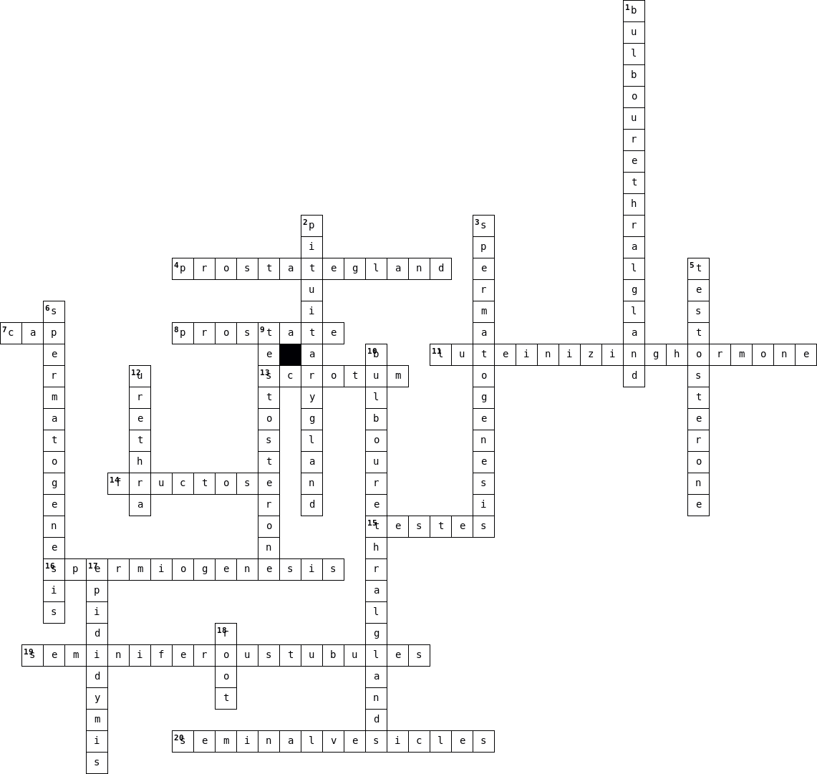

  Across
  4. | prostate-specific make 20-30% of semen
  7. | second phase of spermiogenesis
  8. | secretes thin, milky, and alkaline semen
  11. | stimulates production of testosterone
  13. | regulates the temperature of the testes
  14. | source energy for the spermatozoa
  15. | 5% of semen produced there
  16. | last phase in the formation of the male sex cells
  19. | coiled masses of tubes in the testes
  20. | site for production of the fructose in semen
  Down
  1. | clear mucus produced there
  2. | produces FSH and LH
  3. | FSH stimulates which process
  5. | LH stimulates its production
  6. | process of sperm production
  9. | stimulates the development of the male secondary sexual features
  10. | secrete an alkaline mucus-like fluid
  12. | ejaculatory duct empties spermatozoa into
  17. | long coiled tube that lays on the back of the testicle
  18. | part of the penis attached to the abdomen wall

